**Create your AWS EC2 Ubuntu virtual machine and access it by using SSH from your local Linux virtual machine (no PuTTY).**

1. Install VirtualBox or VMWare on your local laptop/PC.
2. Install Ubuntu 18.04 Virtual Machine on your local laptop/PC.

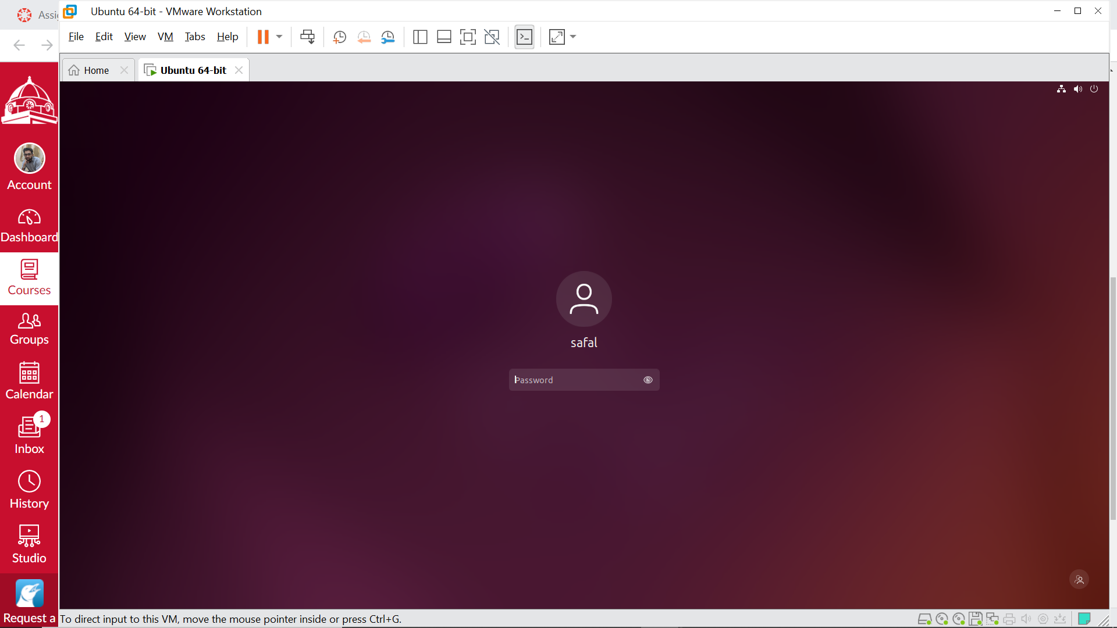

1. Create your AWS EC2 Ubuntu virtual machine and access it by using SSH from your local Linux virtual machine (no PuTTY).

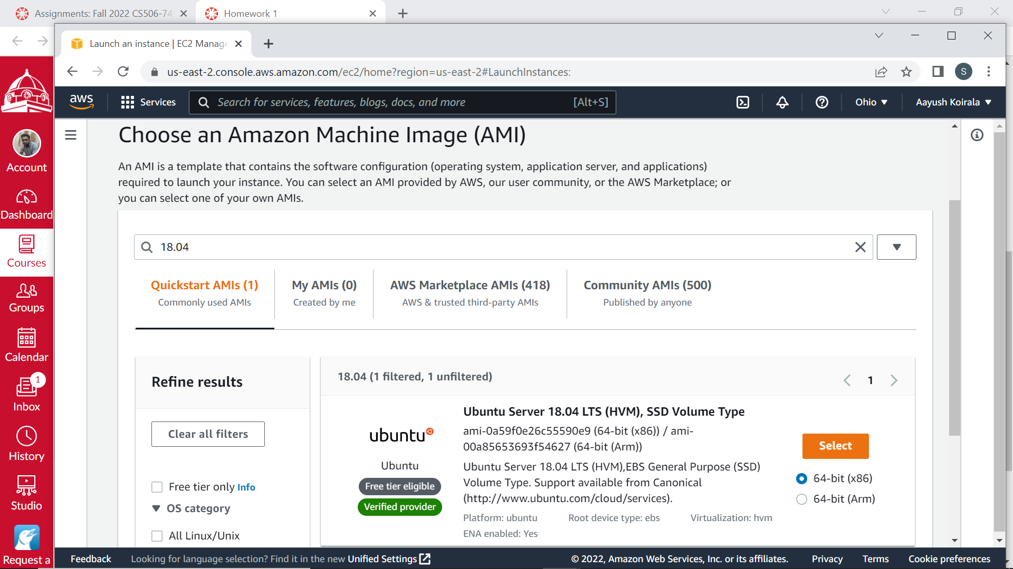

* Install an ubuntu Virtual Machine on your computer.



* Install an ubuntu EC2 instance on AWS cloud.

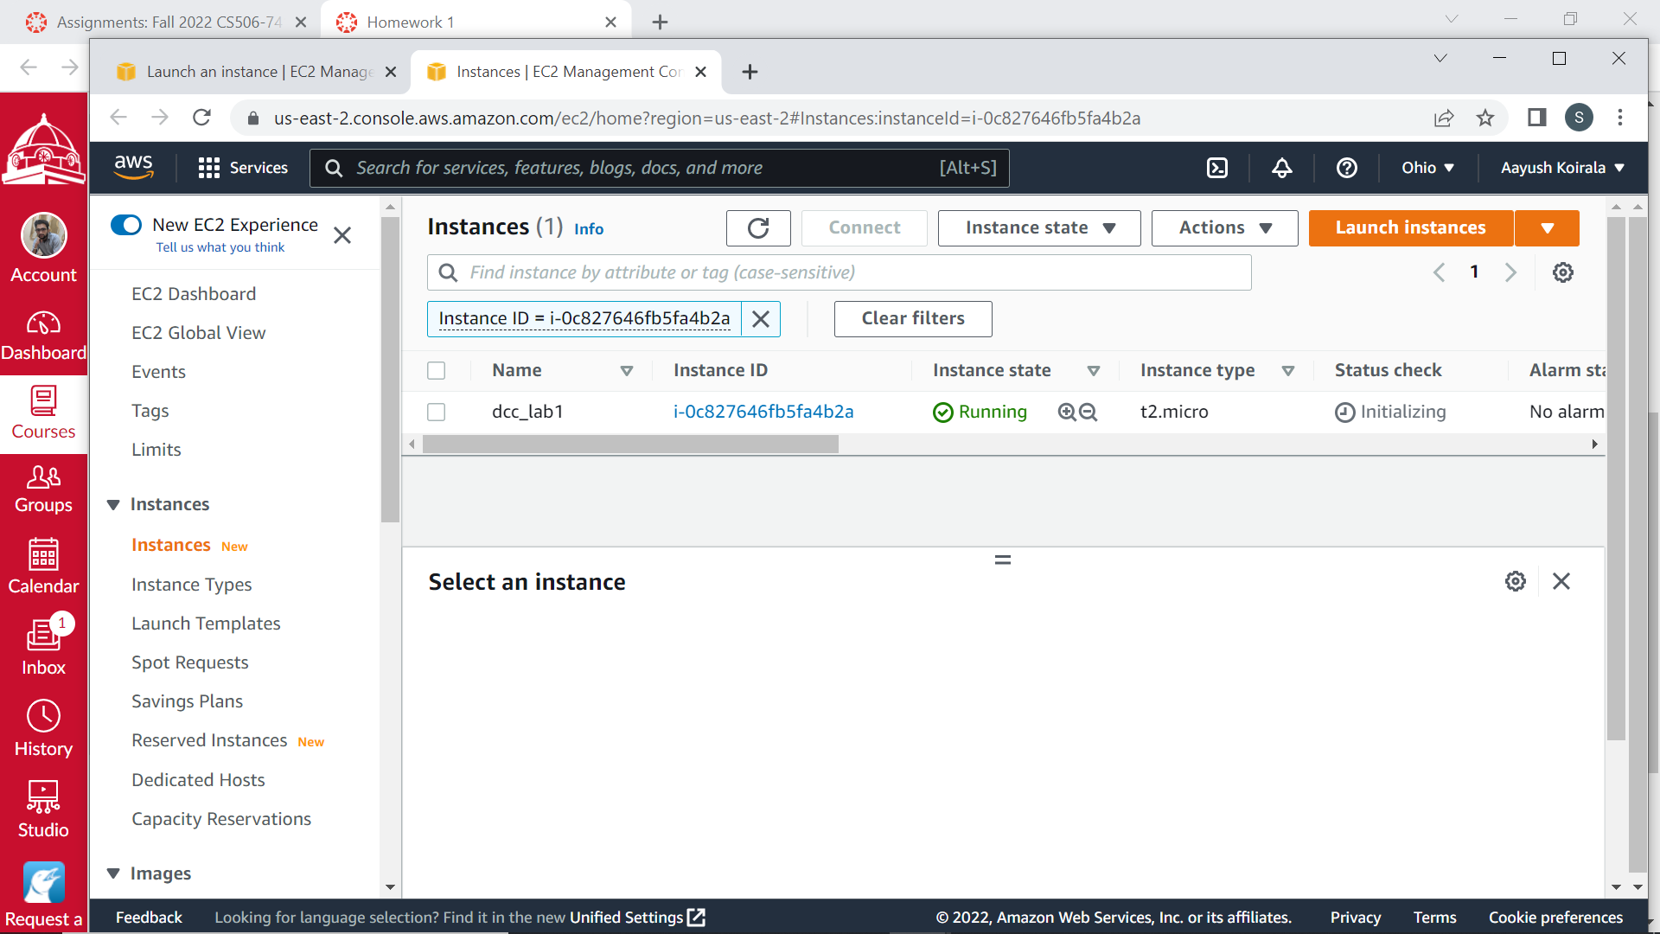

* Access the ubuntu EC2 instance from the ubuntu Virtual Machine on your computer by using SSH command.

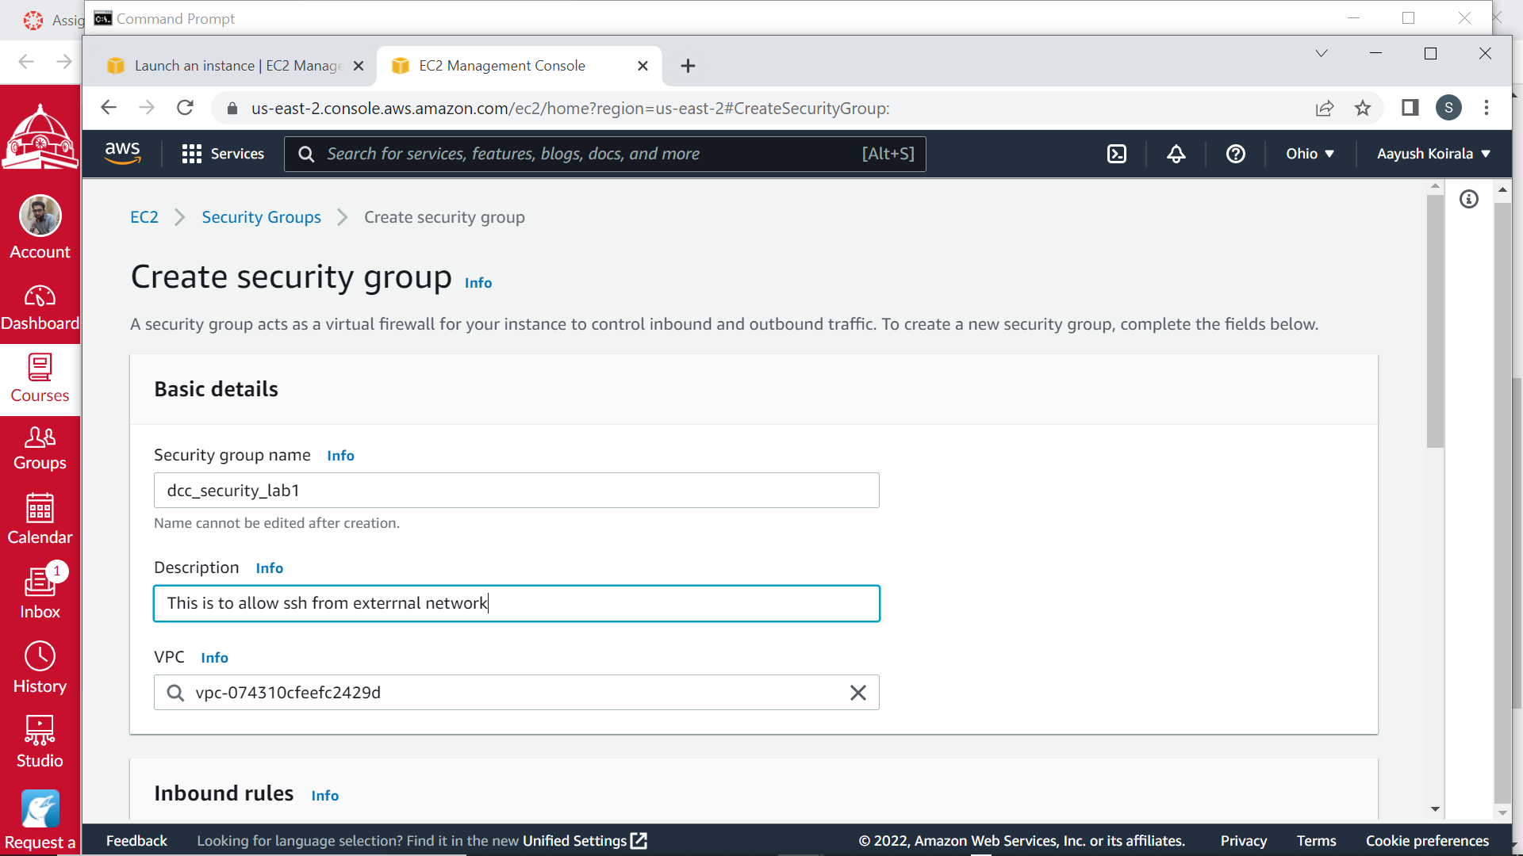

Ubuntu vmware virtual machine IP : 192.168.253.128

Accessing Vmware virtual machine from local cmd

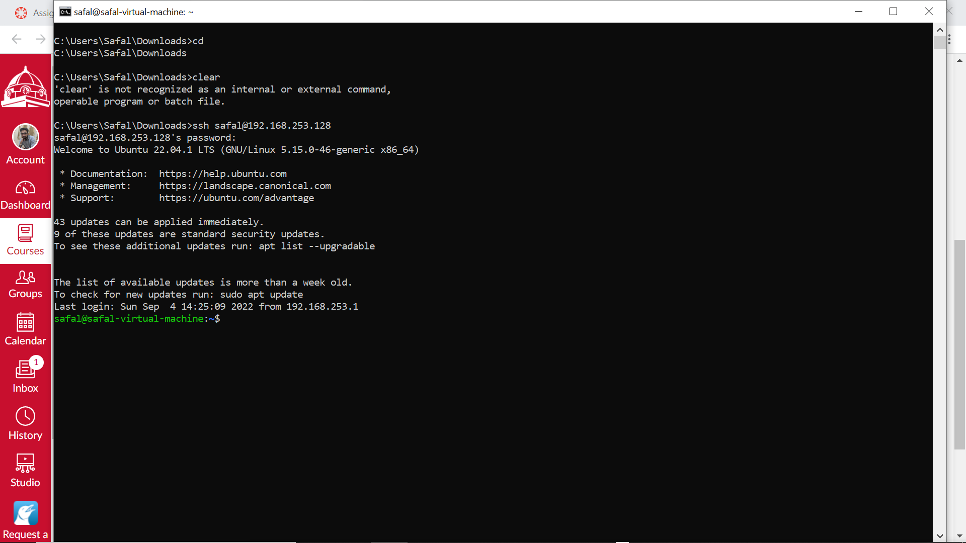

Ec2 instance ssh key : dcc_lab1.pem

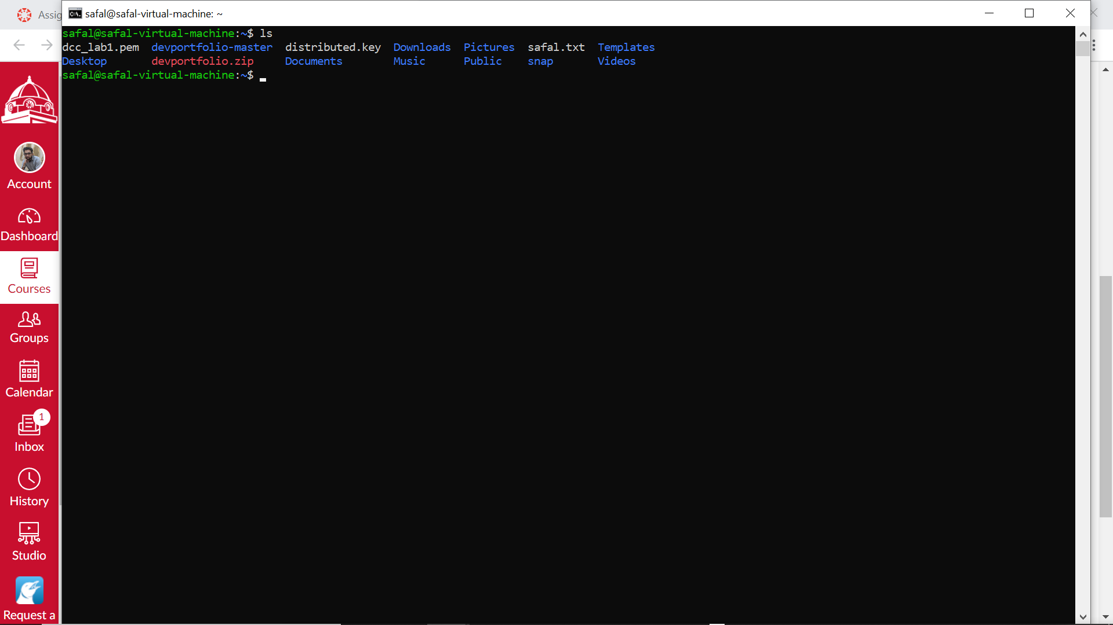

Accessing ec2 instance from local virtual machine

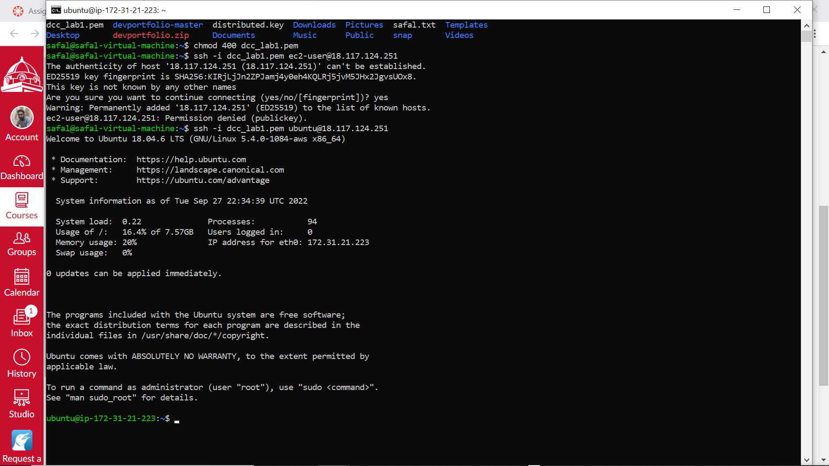

* Copy a file from your ubuntu Virtual Machine to your ubuntu EC2 instance by using SCP command.

1. Copy a file from your local Ubuntu 18.04 VM to your AWS EC2 Ubuntu VM.

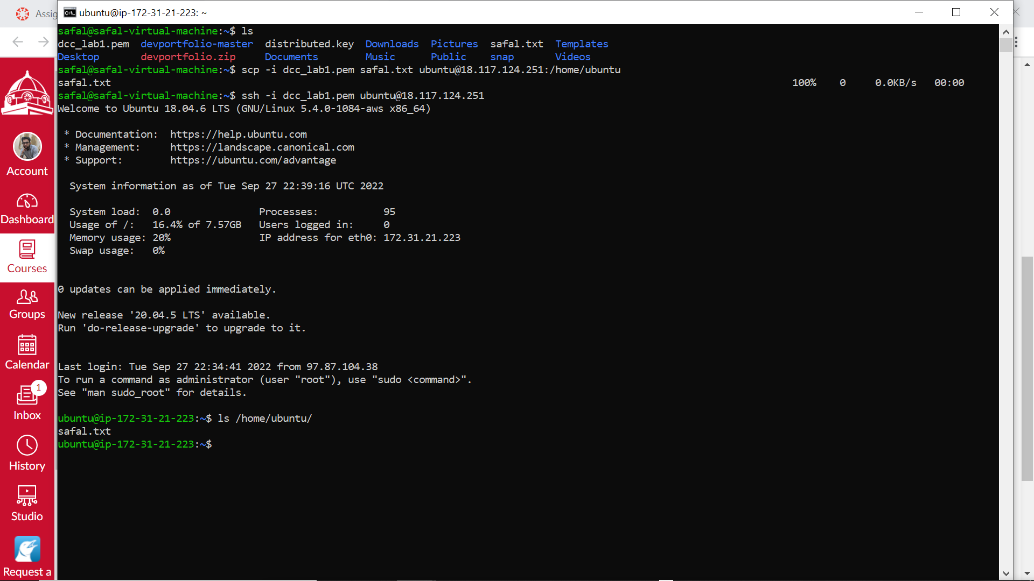

A file Safal.txt has been copied to ec2 instance under Ubuntu user.